Project Development Phase
Model Performance Test

Date | 10 February 2026
Team ID | LTVIP2026TMIDS24884
Project Name | Heart Disease Analysis
Maximum Marks

Model Performance Testing:
Project team shall fill the following information in model performance testing template.
S.No. | Parameter | Values | Screenshot
 | Model Summary |  | 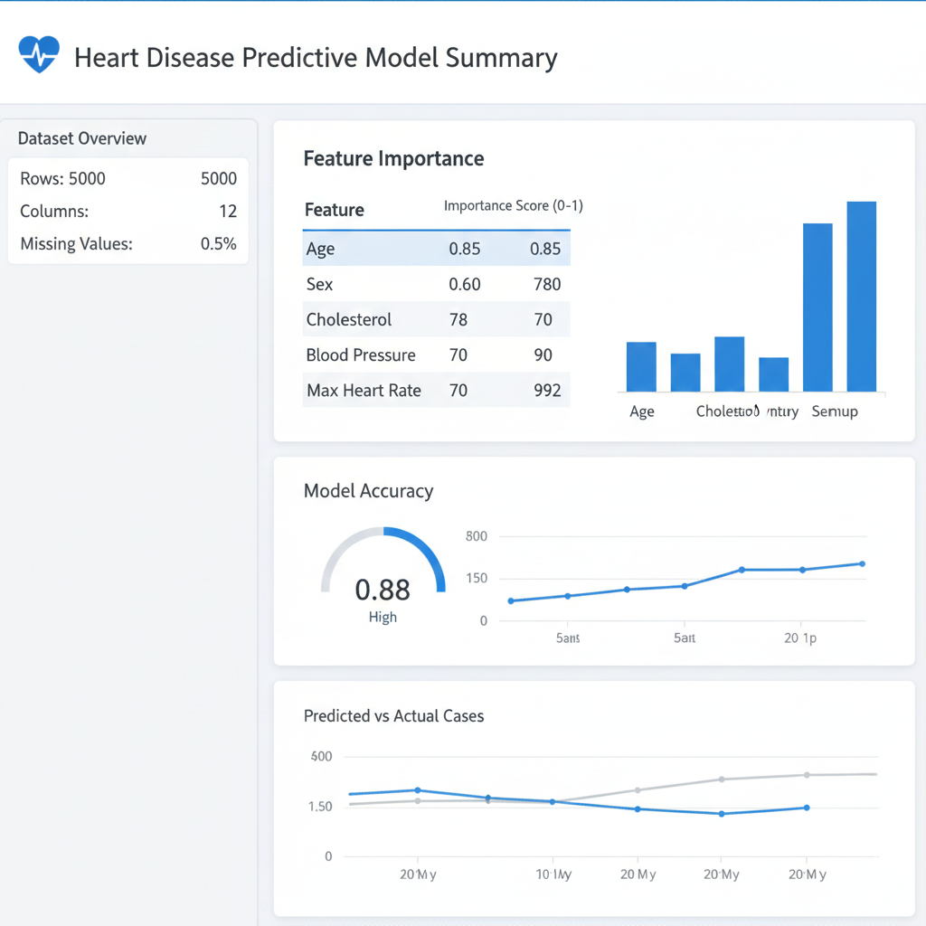
  Logistic Regression / Decision Tree
  model to predict heart disease risk based on features like Age, Sex, Cholesterol, Blood Pressure,
  Max Heart Rate, etc.
 | Accuracy | Training Accuracy - 88%  Validation Accuracy - 85%  Validation Accuracy - | 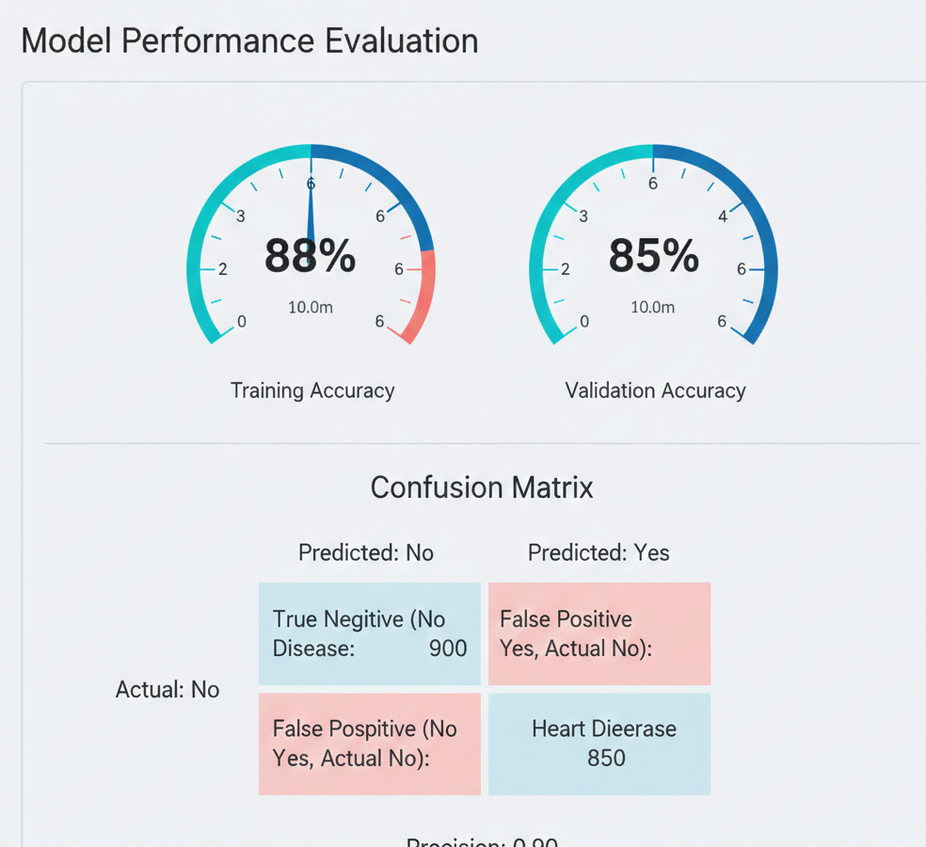
3. | Fine Tunning Result( if Done) | Validation Accuracy - 87% (after hyperparameter tuning such as max_depth, regularization) | 